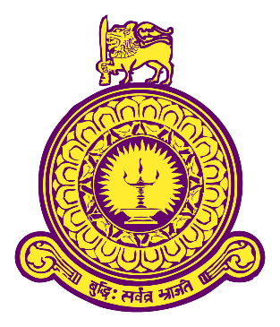

THE EFFECTIVENESS OF THE TRAINING AND DEVELOPMENT OF EMPLOYEE PERFORMANCE IN PROFESSIONAL FOOD AND BEVERAGE SERVICE IN HOTEL OPERATION IN SRI LANKA WITH SPECIAL REFERENCE TO HOTELS IN DOWN SOUTH

A THESIS SUBMITTED TO THE FULFILMENT OF
THE REQUIREMENTS FOR THE DEGREE OF
MASTERS IN TOURISM ECONOMICS AND HOTEL MANAGEMENT

DEPARTMENT OF ECONOMICS, FACULTY OF ARTS
UNIVERSITY OF COLOMBO

Name : T.M.K.C.S.R.Pieris

ABSTRACT

Training is a necessity in the workplace. Without it, employees don't have a firm grasp on their responsibilities or duties. Employee training refers to programs that provide workers with information, new skills, or professional development opportunities. This study is to analysis effectiveness of the training and development of employee performance in professional food and Beverage service in hotel operation in Sri Lanka with special reference to hotels in down south. To achieve this main purpose both descriptive and analytical approaches were done to analyse research findings as per the research objectives with the help of SPSS. To interpret the practice of training and development in the stated hotels, the statistical tool used for the analysis and presentation of data in this study was the Statistical Package for the Social Sciences (SPSS) version 23. The data for this study was collected using a questionnaire and unstructured interview schedule to identified sample respondents. The total of 150 questionnaires were circulated and 102 were collected that accounts 96 % response rate, 12 of them were unfiled no questionnaires were discarded due to missing data. The results of the findings indicated that training and development affects employees’ performance and hotel effectiveness, which implies that effort, must be made to ensure that employees’ skills and knowledge are fully underutilized through adequate and timely training design and implementation. Employers should be provided with more training programs in order to reduce the cost of recruiting and training new staff members. On the other hand, the provision of feedback to employees after training is recommended in order for employees to become aware of areas where they can improve their performance Individual should be more proactive and seek to be more creative and innovative to contribute their quota through their profession and skill.

Key words: hotel industry, training, development, performance

